2253 CFGS Web Application Development

Module 2 – Data Bases

UF2 – SQL Language: DDL and DML
NF4 – Data Manipulation Language
ACTIVITY

ACTIVITY DONE BY | 1DAW

Activity 9: Using SELECT statements

Description

Implement next SQL DML statements in AGENCY database.

The Entity-Relationship:

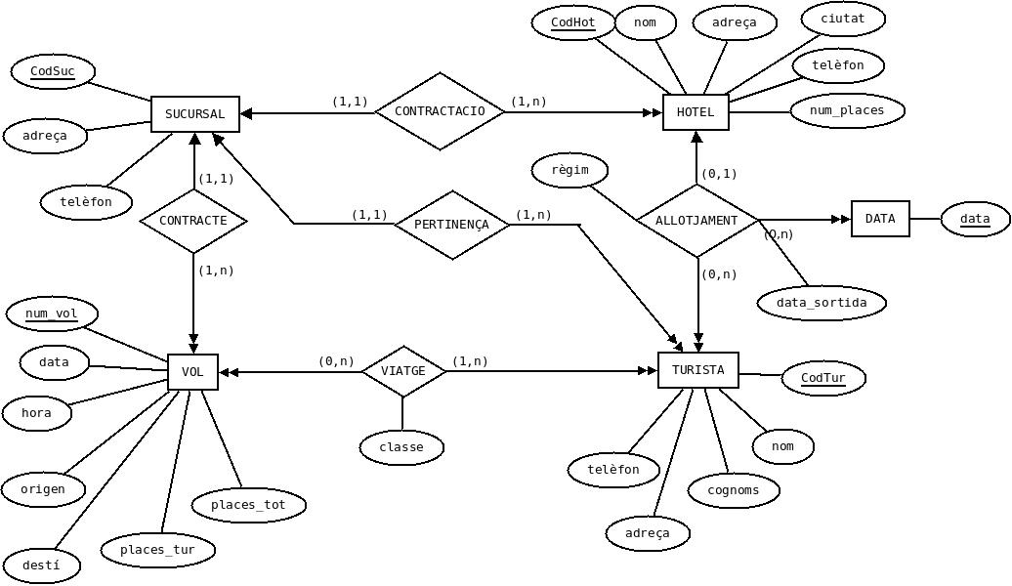

And the relational model:

SUCURSAL (CodSuc, adreca, telefon)

VOL (num_vol, data, hora, origen, desti, places_tur, places_tot, CodSuc)
ON {CodSuc} REFERENCIA SUCURSAL (CodSuc)

HOTEL (CodHot, nom, adreça, ciutat, telefon, num_places, CodSuc)
ON {CodSuc} REFERENCIA SUCURSAL (CodSuc)

TURISTA (CodTur, nom, cognoms, adreca, telefon, CodSuc)
ON {CodSuc} REFERENCIA SUCURSAL (CodSuc)

ALLOTJAMENT (CodTur, data_ini, CodHot, data_sortida, regim)
ON {CodTur} REFERENCIA TURISTA (CodTur)
ON {CodHot} REFERENCIA HOTEL (CodHot)

VIATGE (CodTur, num_vol, classe)
ON {CodTur} REFERENCIA TURISTA (CodTur)
ON {num_vol} REFERENCIA VOL (num_vol)

1) Select the tourists (all the information) ordered firstly by surname and secondly by name.

SELECT * FROM TURISTA ORDER BY TURISTA.cognoms, TURISTA.nom

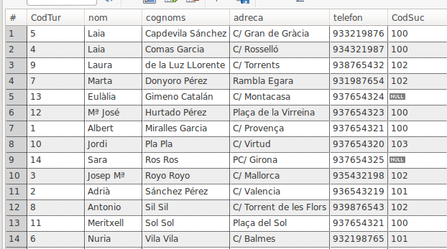

2) Select the hotels (code and name) that work with the agency (sucursal) 101.

SELECT HOTEL.CodHot , HOTEL.nom
FROM HOTEL
WHERE HOTEL.CodSuc=101

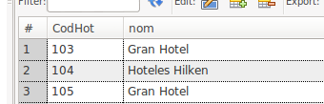

3) Select the tourists (code, name and surname) who belong to the agency (sucursal) located at C/ Sants'.

SELECT TURISTA.CodTur, TURISTA.NOM , TURISTA.cognoms
FROM TURISTA JOIN SUCURSAL ON TURISTA.CodSuc=SUCURSAL.CodSuc
WHERE SUCURSAL.adreca='C/ Sants'

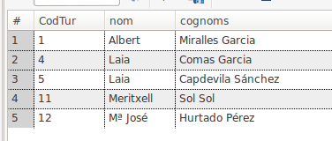

4) Select name, surname, address and phone of all the tourists who have been at a hotel on half board (mitja pensió) between 2013-09-03' and '2013-09-08' both included.

SELECT DISTINCT(TURISTA.nom), TURISTA.cognoms , TURISTA.adreca FROM
TURISTA JOIN ALLOTJAMENT ON TURISTA.CodTur = ALLOTJAMENT.CodTur
WHERE ALLOTJAMENT.regim='mitja pensió' AND ALLOTJAMENT.data_sortida >= '2013-09-03' AND ALLOTJAMENT.data_ini <= '2013-09-08'

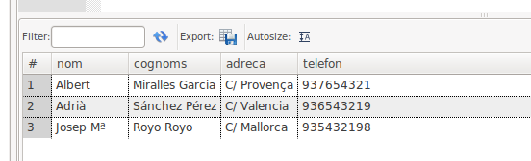

5) Select all the tourists (all the information) whose name begins by 'L'.

SELECT * FROM TURISTA WHERE TURISTA.nom LIKE "L%"

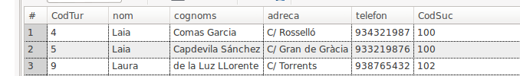

6) Select all the tourists (code, name and surname) who have not hired any flight.
SELECT TURISTA.CodTur , TURISTA.nom , TURISTA.cognoms FROM TURISTA WHERE TURISTA.CodTur NOT IN (SELECT VIATGE.CodTur FROM VIATGE

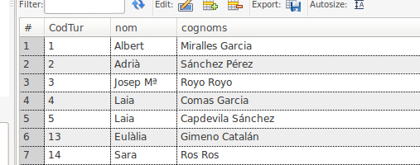

7) Select all the tourists (name and surname) who have not traveled in flight number 1000.

SELECT , TURISTA.nom , TURISTA.cognoms FROM TURISTA WHERE TURISTA.CodTur NOT IN (SELECT VIATGE.CodTur FROM VIATGE WHERE VIATGE.num_VOL = 1000)

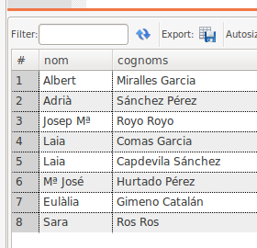

8) For every hotel select the tourist name and surname in the way surname1 surname2, name (for example: Sil Sil, Antonio), hotel name in capital letters, check-in date and number of days that have stayed in the hotel. The list must be ordered firstly by the hotel name and secondly by the tourist surnames. You have to use time functions.

SELECT CONCAT(TURISTA.cognoms , ' , ' , TURISTA.nom) , UPPER(HOTEL.nom) , ALLOTJAMENT.data_ini , (ALLOTJAMENT.data_sortida - ALLOTJAMENT.data_ini)
FROM TURISTA
JOIN ALLOTJAMENT ON TURISTA.CodTur=ALLOTJAMENT.CodTur
JOIN HOTEL ON HOTEL.CodHot = ALLOTJAMENT.CodHot
ORDER BY HOTEL.nom , TURISTA.cognoms

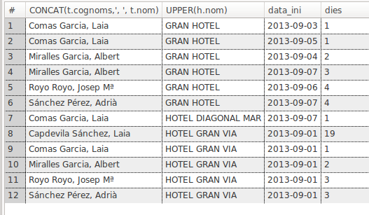

9) Select a completed list of all the tourists with address and phone number of the agency where they are assigned. The list must contain information of the tourists who are not assigned to any agency.

SELECT TURISTA.CodTur , TURISTA.nom, TURISTA.cognoms , TURISTA.adreca , TURISTA.telefon , SUCURSAL.CodSuc , SUCURSAL.adreca , SUCURSAL.telefon
FROM TURISTA LEFT JOIN SUCURSAL ON TURISTA.CodSuc = SUCURSAL.CodSuc

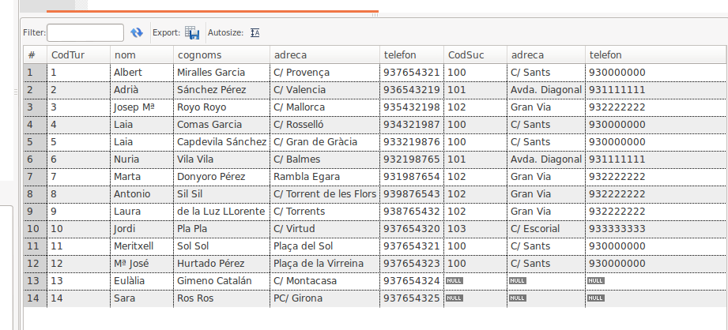

10) Select the flights which have been contracted for more than 2 tourists. The select must contain the flight number, the city from where the flght comes and the destination.

SELECT VIATGE.num_VOL , COUNT(*) as num_passatgers , VOL.origen , VOL.desti
FROM VIATGE JOIN VOL ON VIATGE.num_VOL = VOL.num_VOL
GROUP BY VIATGE.num_VOL
HAVING num_passatgers>2

